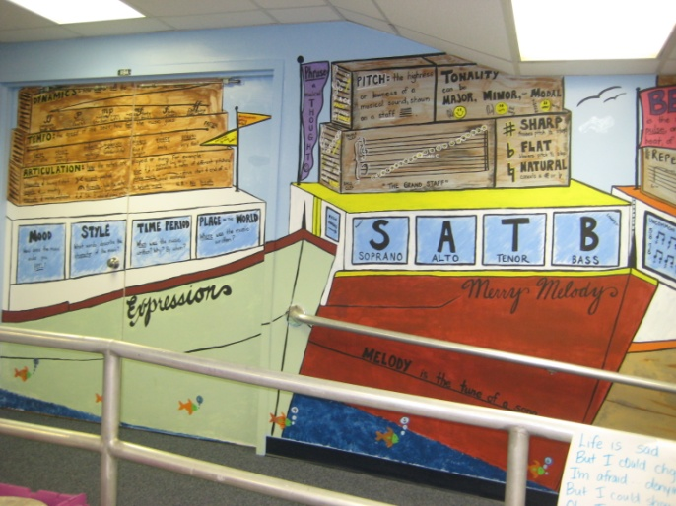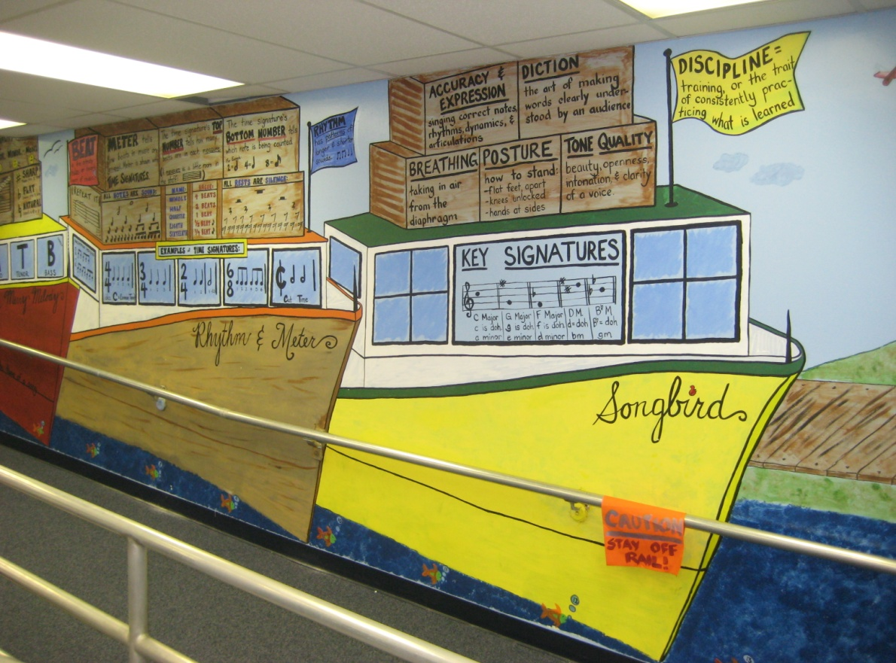

**CRUISE SHIP BOARDWALK MUSIC ROOM**

**ABOVE-** Music Room Ramp (leads to stage)- “boat dock” with 4 lobster boats: *Expression* (Tempo, Dynamics, Articulation traps); *Merry Melody* (Pitch, Grand Staff, Accidentals, Tonality); *Rhythm & Meter* (Notes & Rests, Meters, Beat v. Rhythm); & *Songbird* (Singing Fundamentals, Solfege). **BELOW LEFT-** Closer view of *Rhythm & Meter* curriculum content.

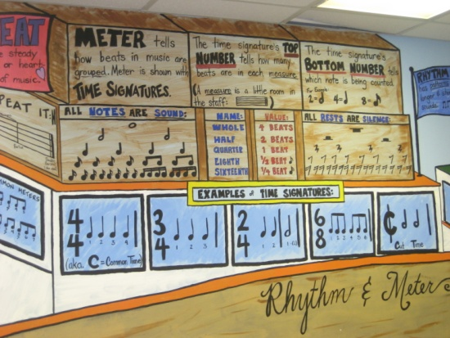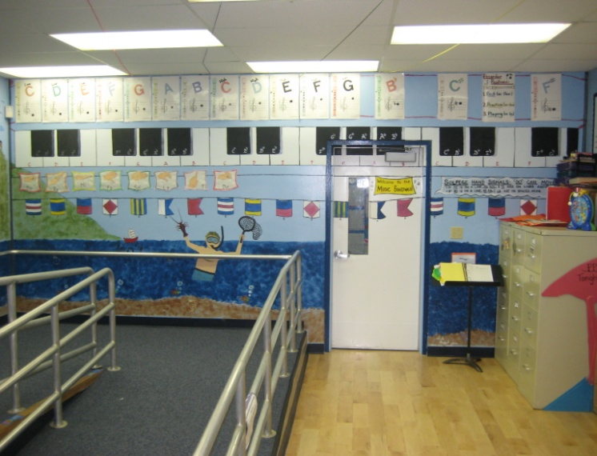 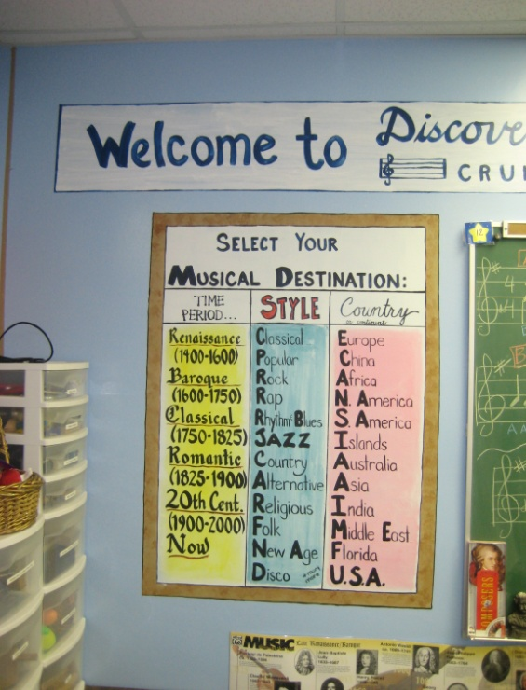

**ABOVE MIDDLE-** “Volleyball” Keyboard/Recorder net w/matching nautical flags. Recorder notes line up w matching letter Keys.

**ABOVE RIGHT-** At the Travel Agent’s Office, Select Your Musical Destination: Time Period, Style, or Country!

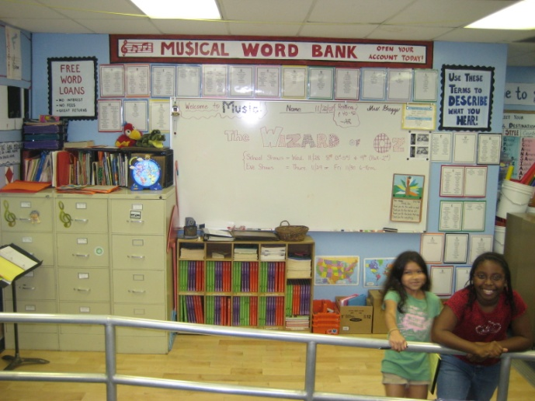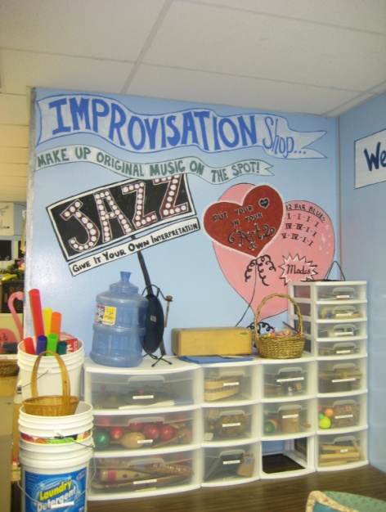 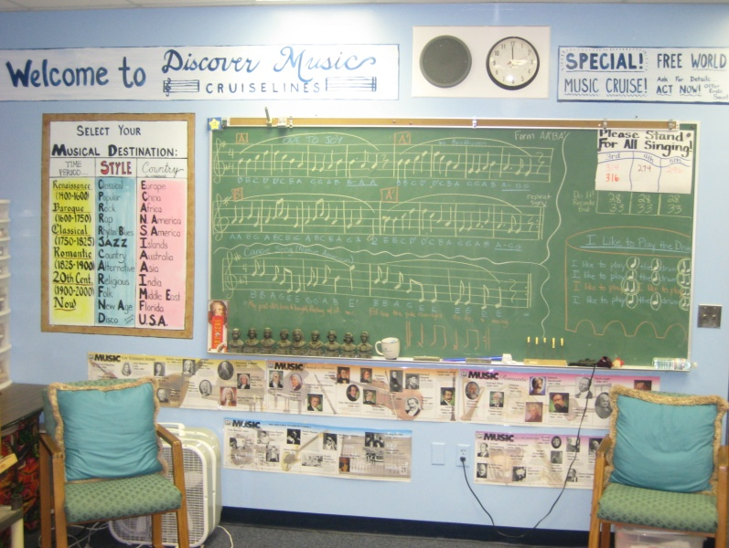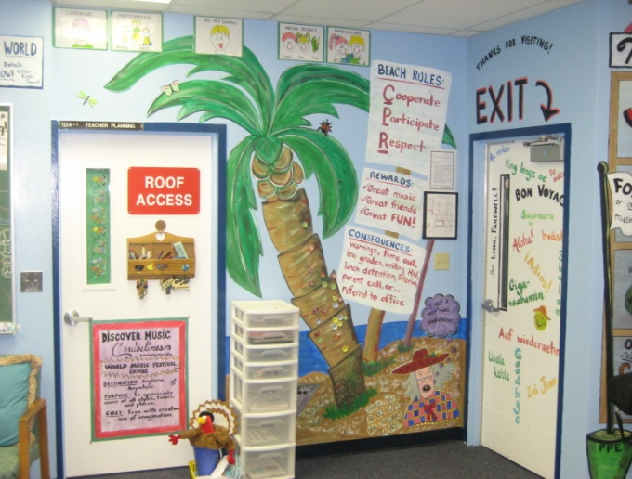 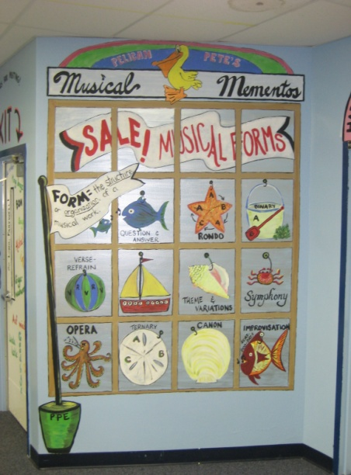 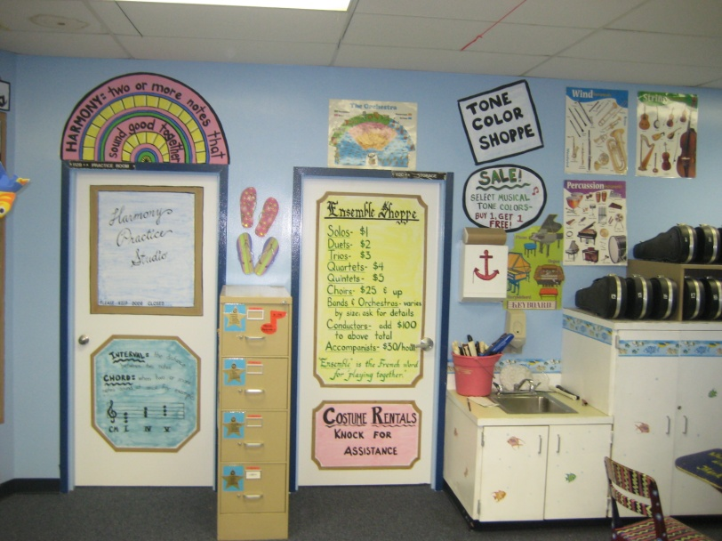

**LEFT**- TRIBES Rules, Rewards, & Consequences Wall; **MIDDLE**- Pelican Pete’s Musical Mementos Shop- Sale on Musical Forms! (carefully check shop windows) **RIGHT**- Harmony Practice Studio & Tone Color Shoppe inside Pelican Pete’s. Choose Strings, Brass, Woodwinds, or Percussion. Ensembles priced by number of members!

**ABOVE LEFT**- Musical Word Bank: Free Word Loans- Open Your Account Today! **MIDDLE**- Jazz Improvisation Shoppe- Put your Heart In Your Art! **RIGHT**- Beethoven’s Ode to Joy on Chalkboard above Famous Musicians Timeline.